**<UCCG Arrangement System>**

**System Design Specification (SDS)**

**<Version 9.0>**

**<14/4/2019>**

**Prepared by**

何朗轩 **1730026028**

李东华**1730026039**

李俊江 **1730026044**

余家慧 **1730026139**

**Computer Science and Technology Program**

**United International College**

1. Document Change Log

|  |  |  |  |
| --- | --- | --- | --- |
| ***Change Date*** | ***Changed By*** | ***Version*** | ***Change Description*** |
| *10/4/2019* | *Langxuan He* | *1.0* | *Prepared Document* |
| 11/4/2019 | Donghua Li | 2.0 | *Add User Interface design* |
| 12/4/2019 | Langxuan He | 3.0 | Add User Interface description |
| 13/4/2019 | Junjiang Li | 4,0 | Add Entities Relationship Diagram |
| 14/4/2019 | Jiahui Yu | 5.0 | Add Class diagram and Control Flow diagram |
| 14/4/2019 | Donghua Li | 6.0 | Update User Interface design |
| 14/4/2019 | Langxuan He | 7.0 | Update User Interface description |
| 14/4/2019 | Langxuan He | 8.0 | Add tools and standard |
| 14/4/2019 | Donghua Li | 9.0 | Add Design Overview |
|  |  |  |  |

1. Table of Contents
2. Document Change Log 2
3. Table of Contents 3
4. Design Overview 4

3.1. Purpose 4

3.2. Target Customer 4

3.3. Aim 4

1. Tools and Standards 5

4.1. Tools 5

4.2. Standards 5

1. User Interface Design 6

5.1. navigation bar 6

5.2. User 7

5.2.1. Login page 7

5.2.2. Reset your password page 8

5.2.3. Register Page 9

5.2.4. Personal Information Page 10

5.2.5. Player registration Page 12

5.2.6. Sign up a competition 13

5.3. For administrator 14

5.3.1. Information edit page 14

5.3.2. Schedule Editing page 15

1. Database Design 17
2. Diagrams 18
3. Design Overview

## 3.1.Purpose

* + *The purpose of this system is to provide an online platform for the annual UIC Game Competition, allowing it to have its routine edited on website and its information stored in database.*
  + *First, every user can use its registration pages to get his or her new account. Normally, a new account has no authority on operating the system. For those which is going to be the staff or the administrator in this platform. They need to talk to the current administrator or the developer of this platform to change their account’s authorities directly in the database for entering the administrative pages.*
  + *Moreover, for an administrator, he or she can edit schedules of each event and information of each user excluding other administrators and developers. Later the edited schedules can be set to be displayed on public pages or drop.*
  + *For other ordinary users, they can sign up as candidates in every event in a Game Competition both as team or individual. In addition, team leaders are allowed to access the information and status his or her teammates.*

## 3.2. Target Customer

* + *Our system is developed for all students in UIC to participate in the annual Game Competition held by CST Academic Society and DS Academic Society.*

## 3.3.Aim

* + *This system helps CST Academic Society and DS Academic Society to have a good platform to undertake this competition.*
  + *This system also allows the all the participants to deal with the management of all the evens they attend.*

1. Tools and Standards

## 4.1. Tools

* HTML 5
* CSS 3
* JavaScript
* Bootstrap 4.1
* Tabler 0.0.32
* Python 3.6
* Flask 1.0
* MySQL/Maria DB

## 4.2. Standards

* Testing on latest stable version of Google Chrome browser (Version 73.0.3683.103 (Official Build) (64-bit) or later) and Mozilla Firefox browser (66.0.3 (64-bit) or later), no longer support IE 8 / IE 9.
* Using HTML5 Standard.
* Using UTF-8 encoding Standard.

1. User Interface Design

## 5.1. navigation bar

Navigation bar are the same style on each page. The UCAS logo will display at the upper left corner .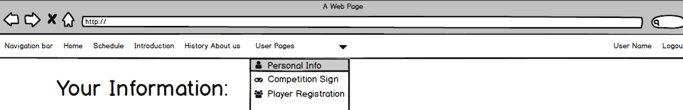

If user has logged in, on the upper right corner will display currently logged-in user name and logout button. If user click on their user name, there will be a drop list for user to view personal information , competition sign up , and player registration.

## 5.2. **User**

### 5.2.1. Login page

This page is a frame of our login page. A form with a username input box, password input box, and a submit button will be displayed on the page. The password entry area will use "*" instead of the raw input. If user forgot his(her) password, there is a “Forget your password ?” link for user to jump to find password page.

### 5.2.2. Reset your password page

For protect personal privacy. User have to reset his(her) password if he(she) lost password. User need to input his account and click on the next button .Then it will turn to second step security check, user need to answer two security questions which has set by user and input his phone number that has bonded with account in order to get a Dynamic Verification Code. Then user need to click the confirm button. If the input informations match the information in the data base and Dynamic Verification Code is right, it will jump to the change password page. User need to set a new password and retype it to confirm change. Then click on the confirm button, the new password has successfully reset.

### 5.2.3. Register Page

This is the register page for new user who want to join the UCCG System to create an account. User need to input account name, password, confirm of password , set two security question, bound the account with user’s phone number and finally click on the confirm button. If everything is validated ,the new user account will be created and an alert message will be displayed as picture shows.

### 5.2.4. Personal Information Page

This is a Personal information page. User can view and edit their basic information. If user want to join a team or a match, he(she) must have, username , student ID, Email Address. The default value of these three are (null) . If user want to edit personal information, he(she) need to click on the edit button and start the edit.Every information can be edited by user except ‘account’ and ‘team’. If 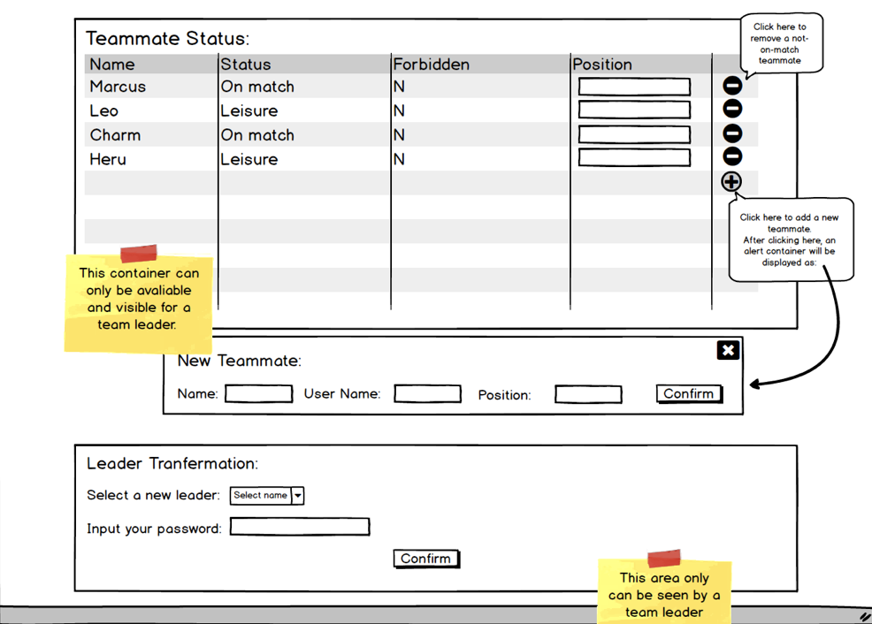edit is done, user need to click on save button so that the information that user has edited will update to database.

If user is a leader of a team ,he(she)can view and modify its team members.Leader also can transform the leader to one of his team member on his personal information page. Leader need to select the the name of the new leader and input password to confirm the transformation.

### 5.2.5. Player registration Page

This is a player registration page. User can resist as team or individual player. As individual player, user need to input user ID(account), user password. As a team, user will act as team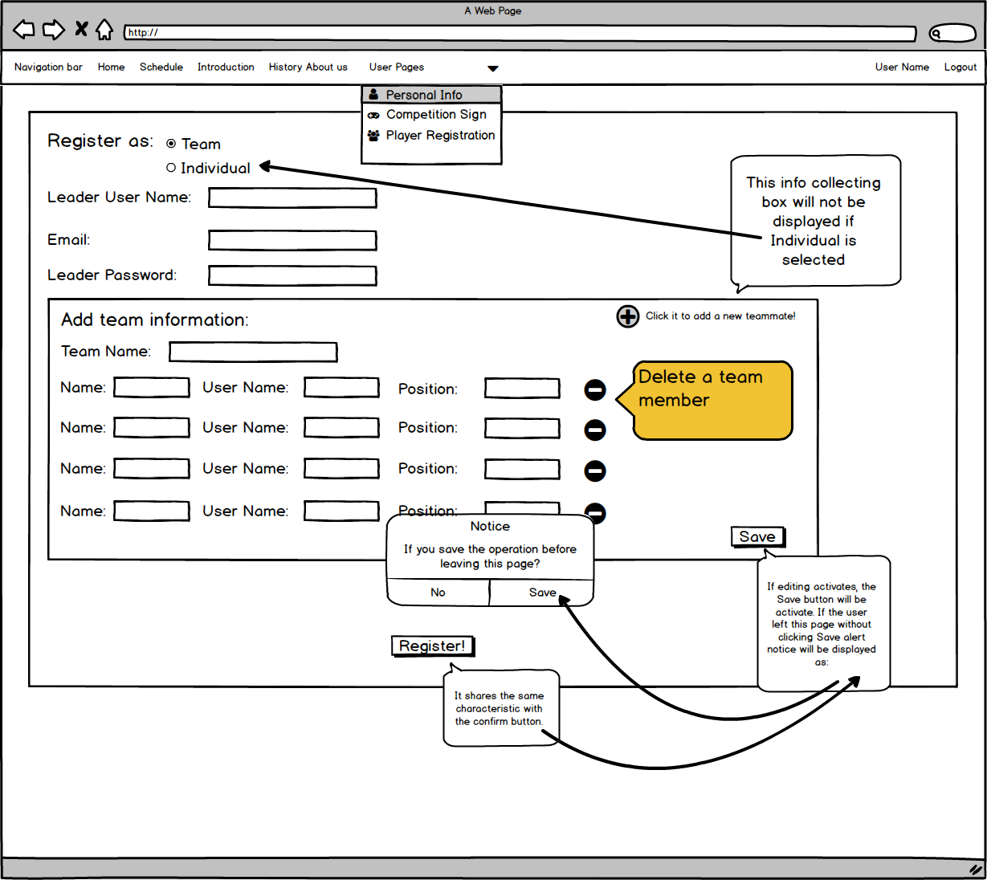 leader. Team need at least one team member except leader. Leader will input team name, teammates information(account, username),select position and click the save button. Finally user need to click “Register!” Button to commit.

### 5.2.6. Sign up a competition

This is a sign up a competition page. User who has registered as a player can sign up an existing competition. As an individual participator ,user need to input account ,password and select individual event. As a team , leader need input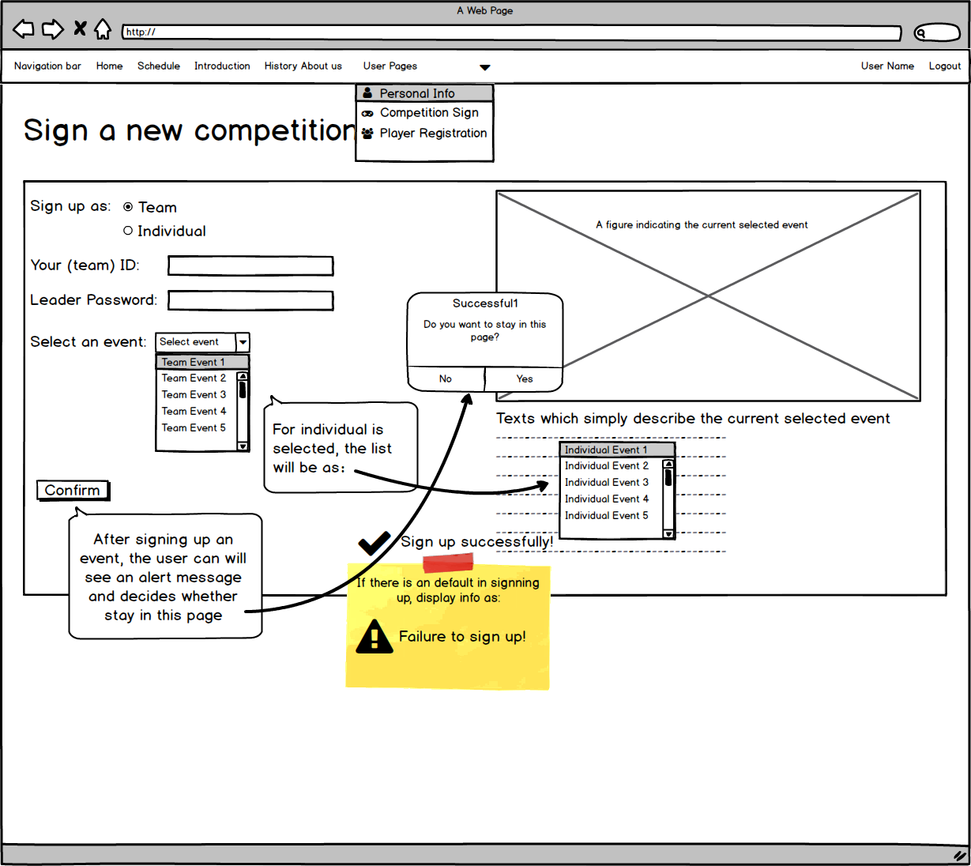 team ID, leader password and select a team event. Noted that, if the team member is smaller than the event required and any other invalid input.After click on the confirm button, there will display information : Failure to sign up and information won’t update to database.

## 5.3. For administrator

### 5.3.1. Information edit page

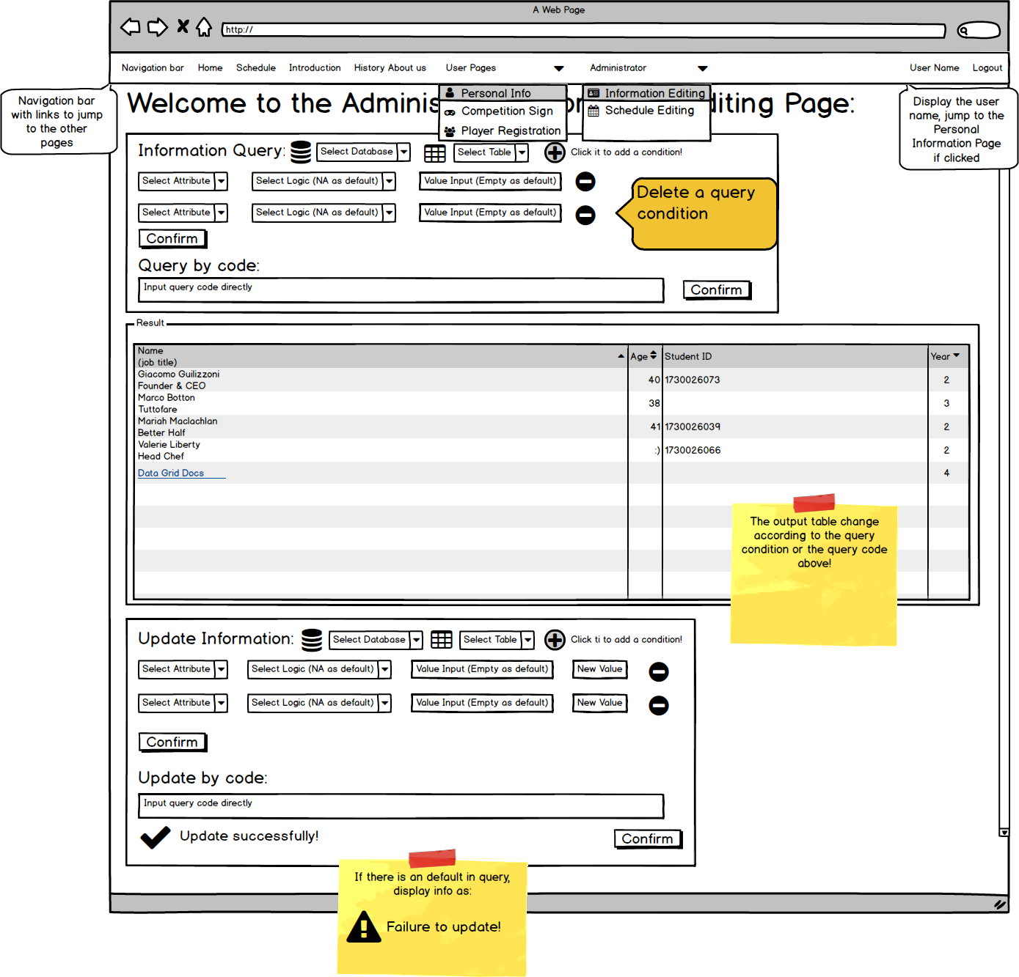

This is an information page only for administrator. Administrators can view and modify all data in all databases. Administrator need to select database and table first. Then this page provide two ways to view and update: one is that user need choose attributes, choose view logic or update logic and input value i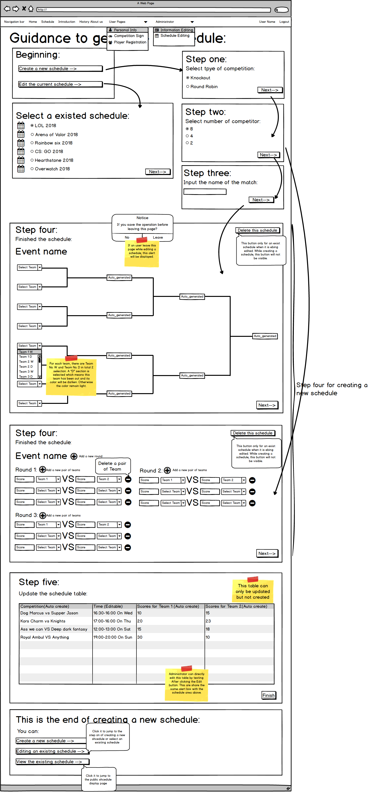f need and click the confirm button. In the middle of the page, it will shows the results the administrator want; Another is administrator can use sql code to do the same thing above, and code will be executed after click on the confirm button.

### 5.3.2. Schedule Editing page

This is a schedule editing page. Administrators can manage matches in this page. At beginning, administrator should choose the option he(she) want to.

If choose create a match, step one administrator should choose a matching mode. After that, set the number of competitors: Knockout provide 2,4 and 8 participants mode ; Round Robin need input the number. Step three, input match name and then the page will jump to the schedule arrangement page as picture step 4 shows.If the schedule arrangement is done, click on the next button, it will show the time editing page for administrator to set time for each match. Finally, if everything has done, the new match will update to database.

If choose edit a match ,administrator need to choose one match that has created. Then jump to the similar page as create a match in step 4 which match informations that was set before will display in the page, and there is a new button called delete schedule for administrator to delete the match. Administrator can edit team arrangement.If edit has done, click on the next button to edit time. Finally, click on the finish button, the new match informations will be updated.

1. Database Design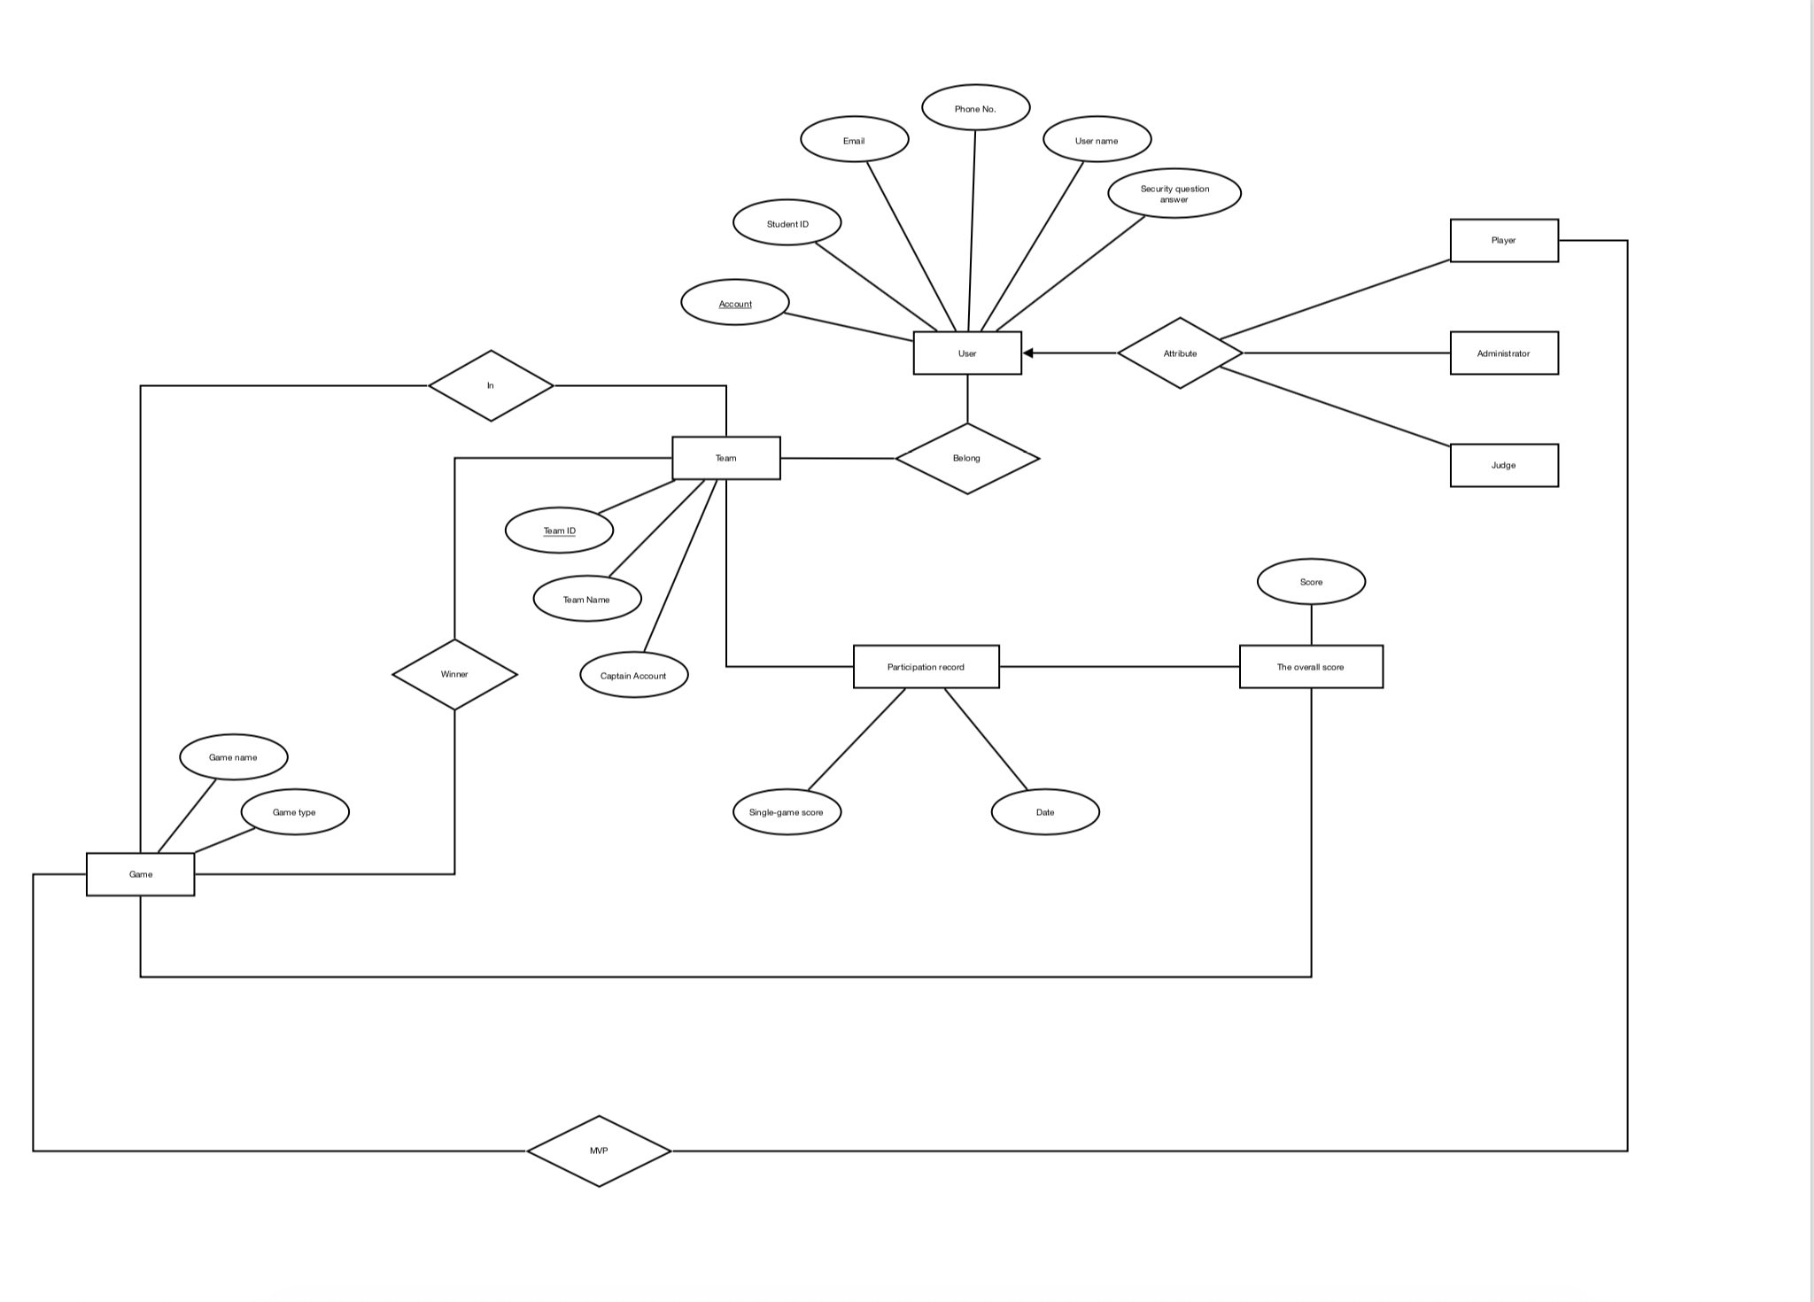
2. Diagrams

*Class Diagram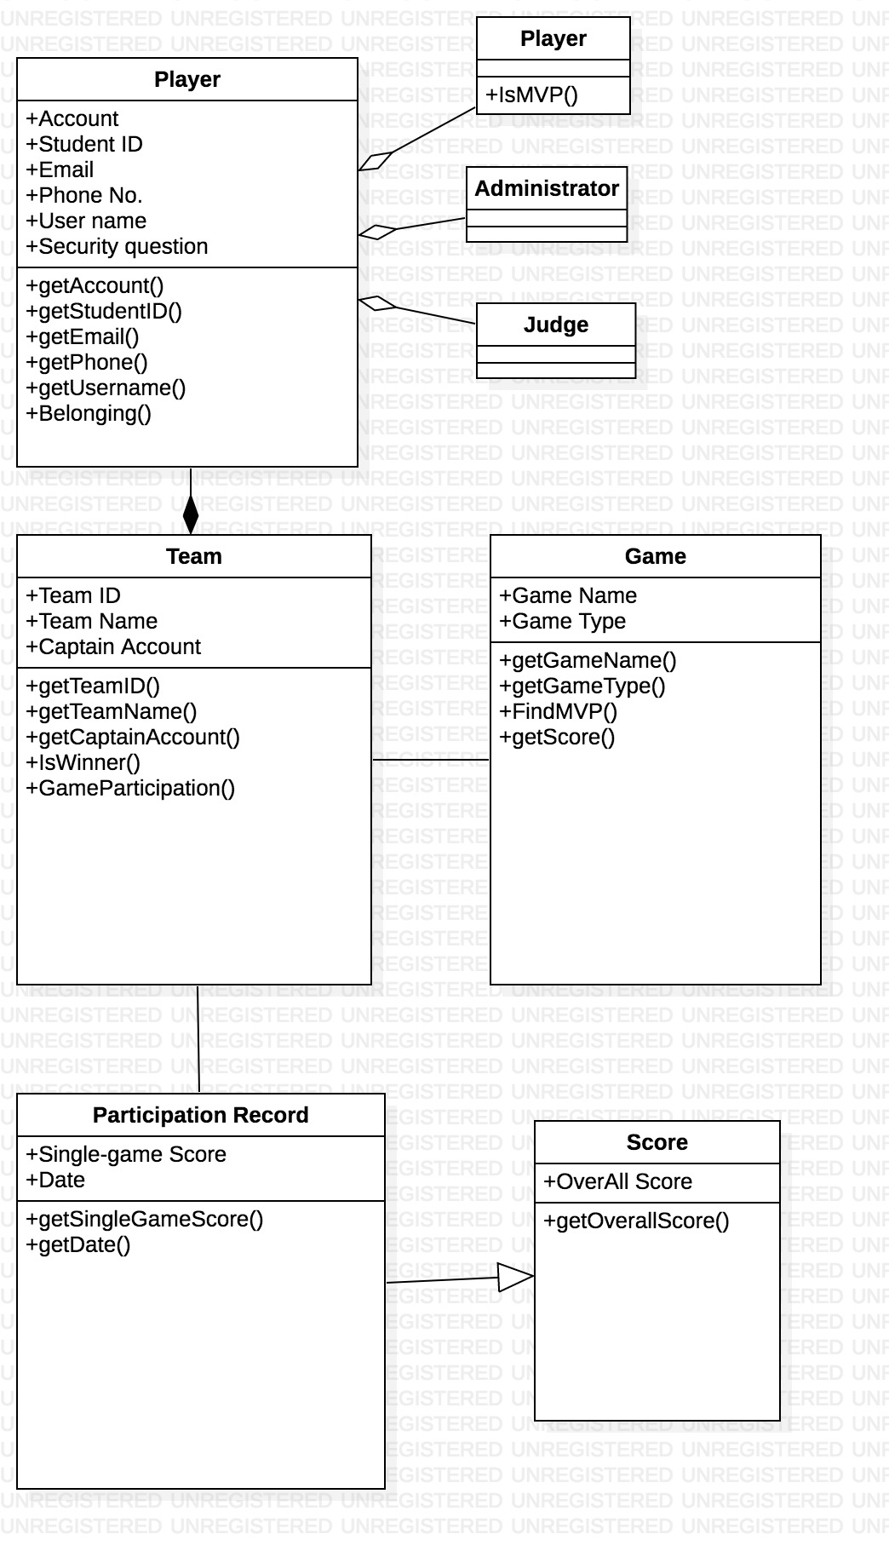*

*Control flow*

*1*、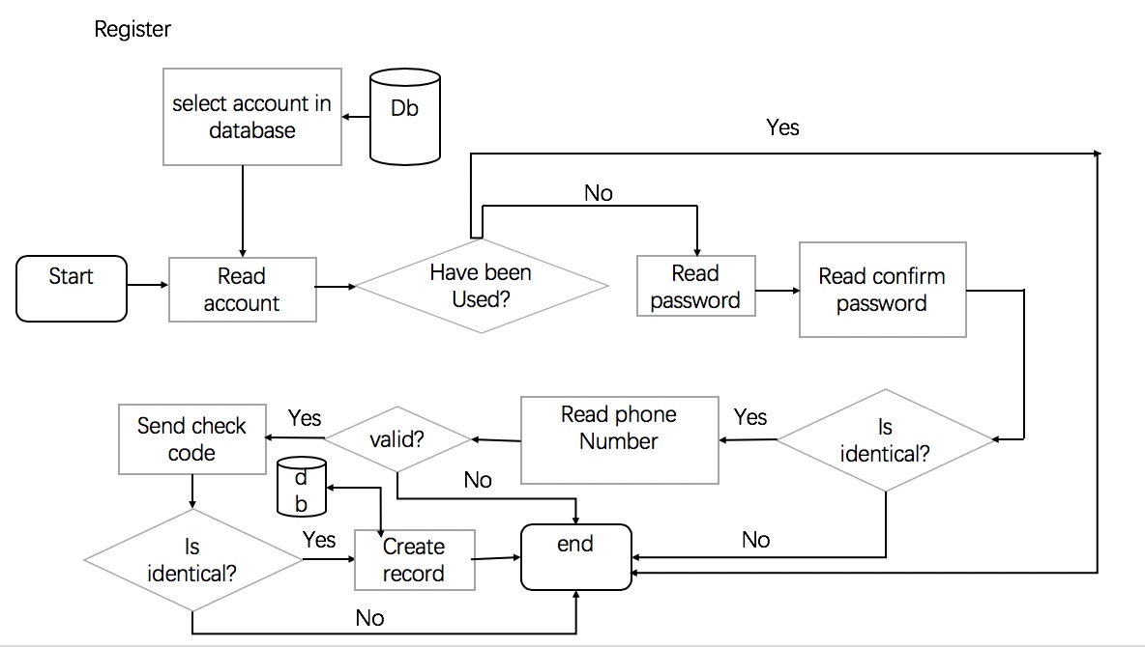

*2*、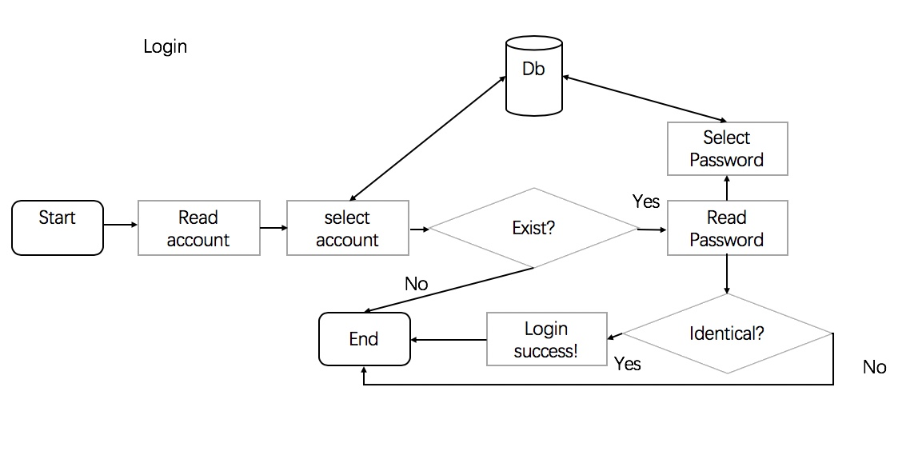

*3*、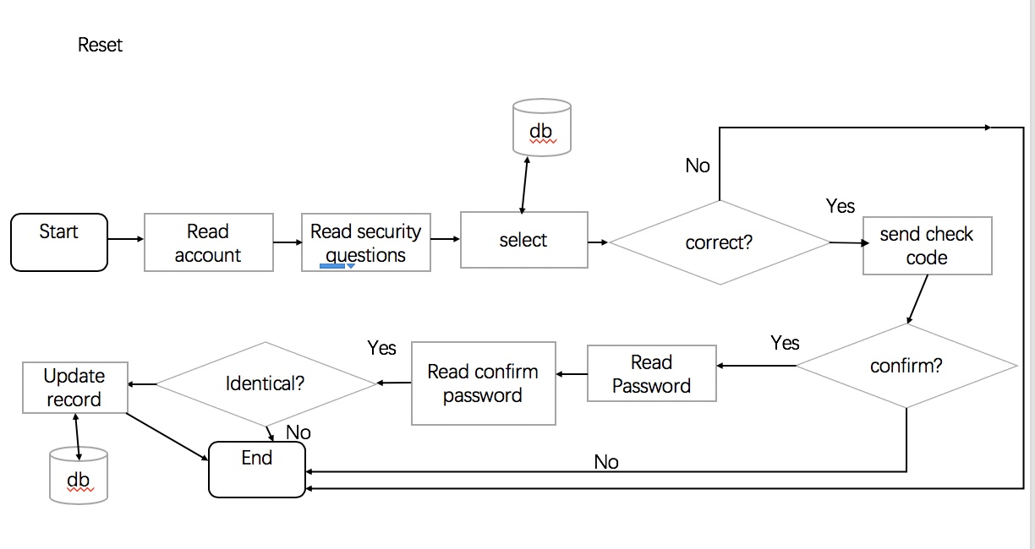

*4*、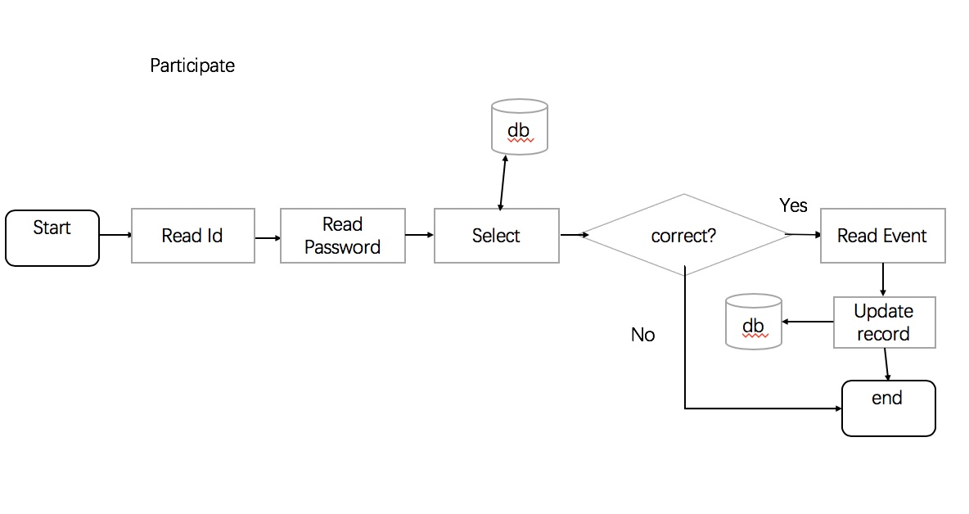

*5*、